LAB ASSIGNMENTS 7: AWS EKS

What is Amazon EKS?
Amazon EKS is a managed service that is used to run Kubernetes on AWS.
Using EKS users don’t have to maintain a Kubernetes control plan on their own.
It is used to automate the deployment, scaling, and maintenance of the containerized application.
It works with most operating systems.

Benefits of Amazon EKS
Normally time-consuming tasks, such as constructing the Kubernetes master
cluster and setting service discovery, Kubernetes primitives, and networking,
are handled by AWS EKS.
Existing tools will almost certainly work through EKS with minimal if any, modifications.

The Kubernetes control plane, comprising the backend persistence layer and API servers,
is provisioned and scaled across multiple AWS availability zones using Amazon EKS,
resulting in high availability and the elimination of a single point of failure.
Unhealthy control plane nodes are identified and replaced, and control plane patching is given.As a result, an AWS-managed Kubernetes cluster that can endure the loss of an availability zone has been created.

Amazon EKS cluster setup:

1. using UI console (we should not do it)
2. using Terraform
3. Using eksctl

In this lab you need to configure EKS using eksctl

3. Using eksctl

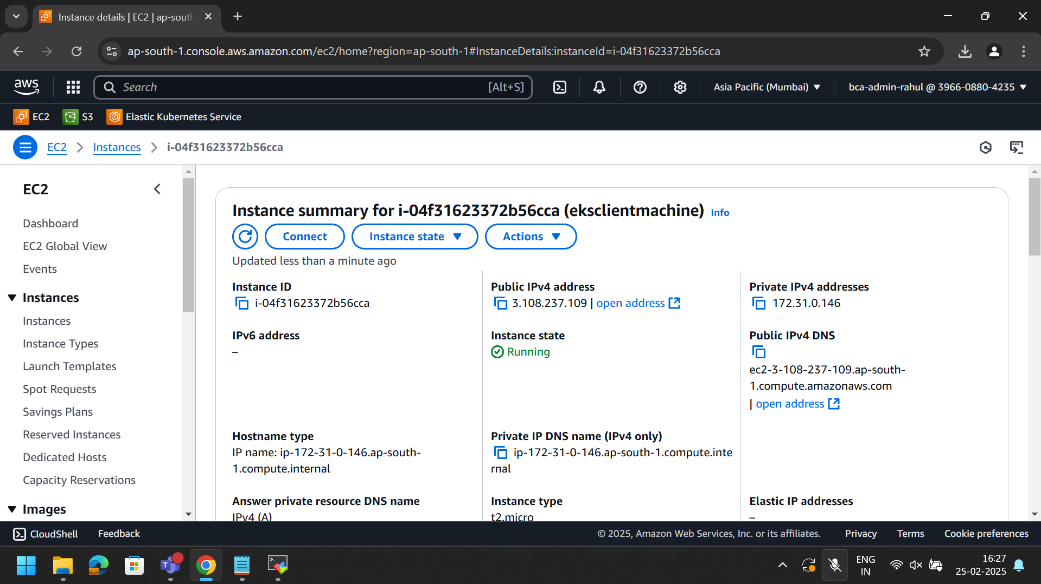

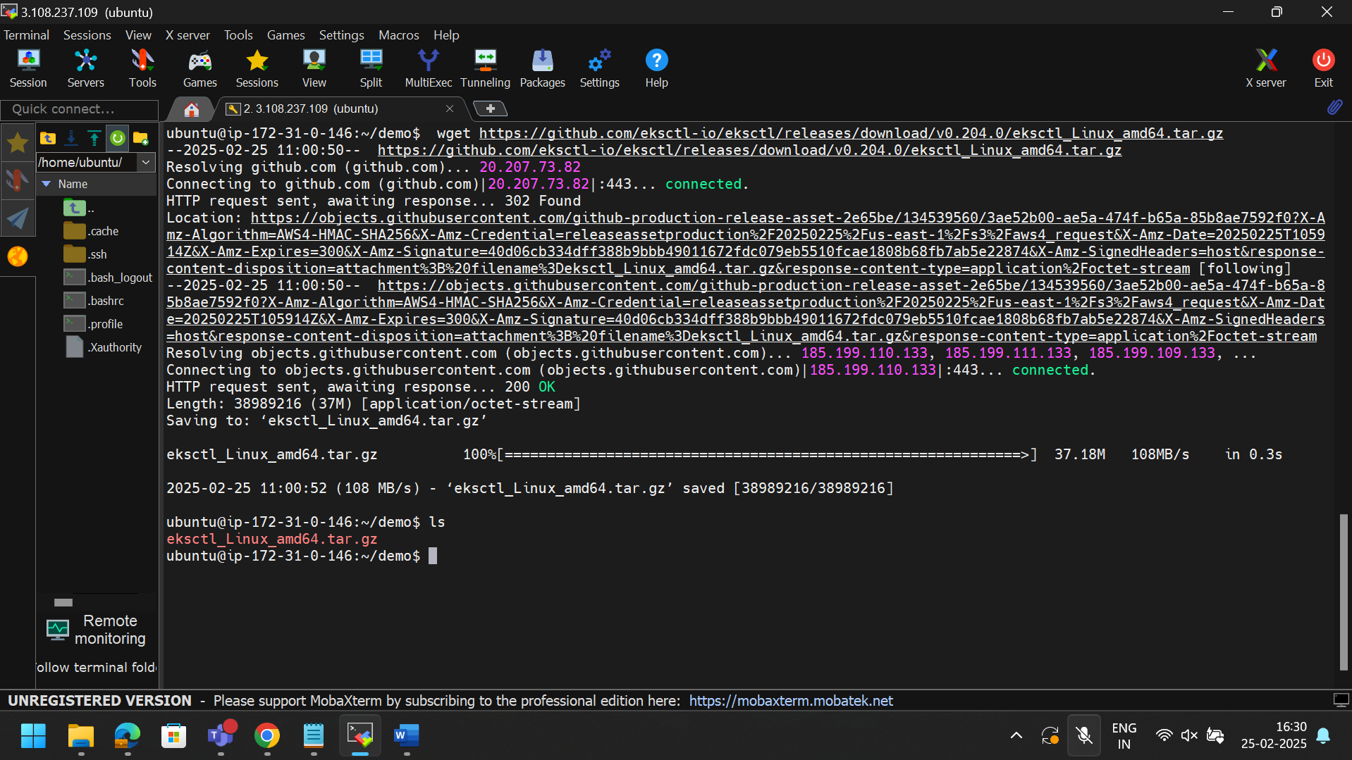

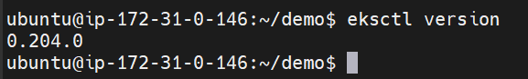

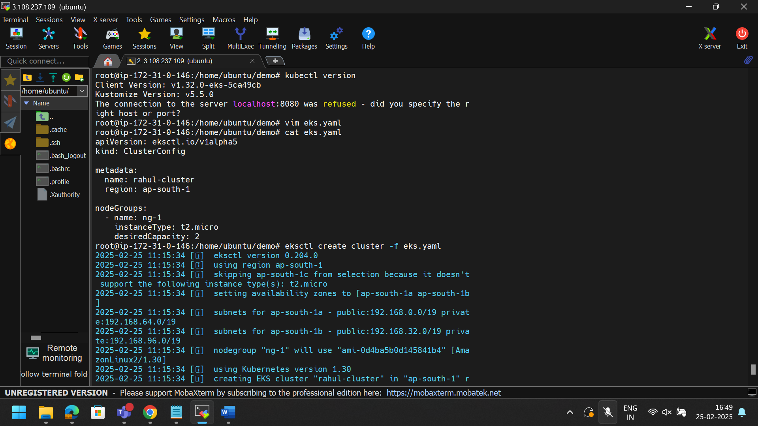

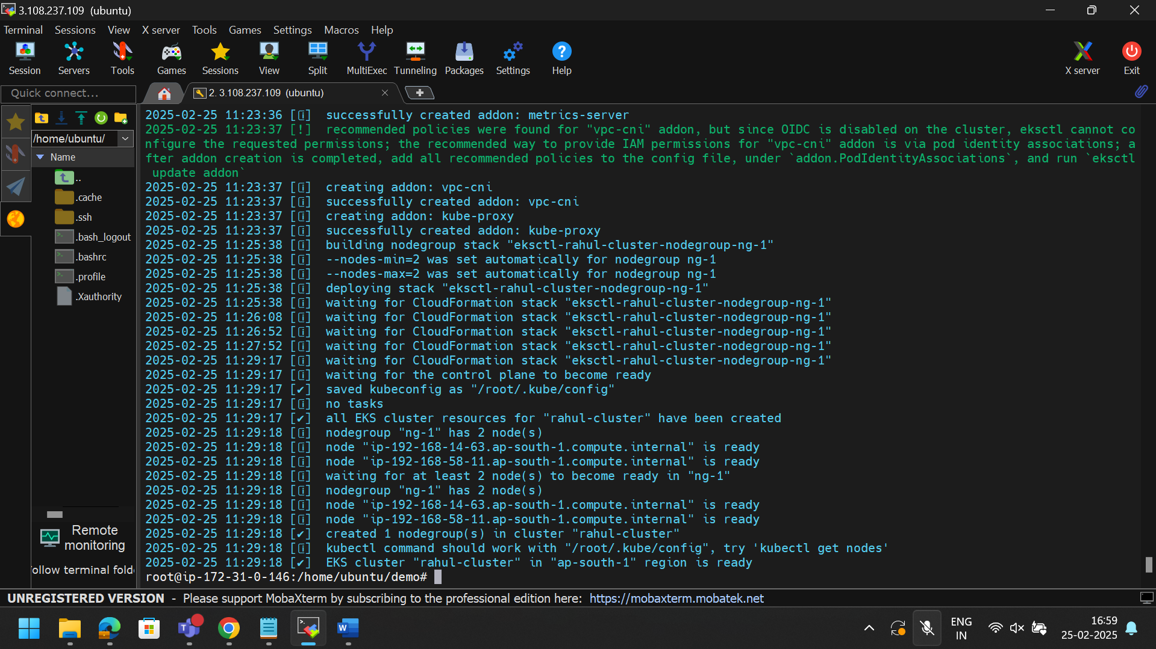

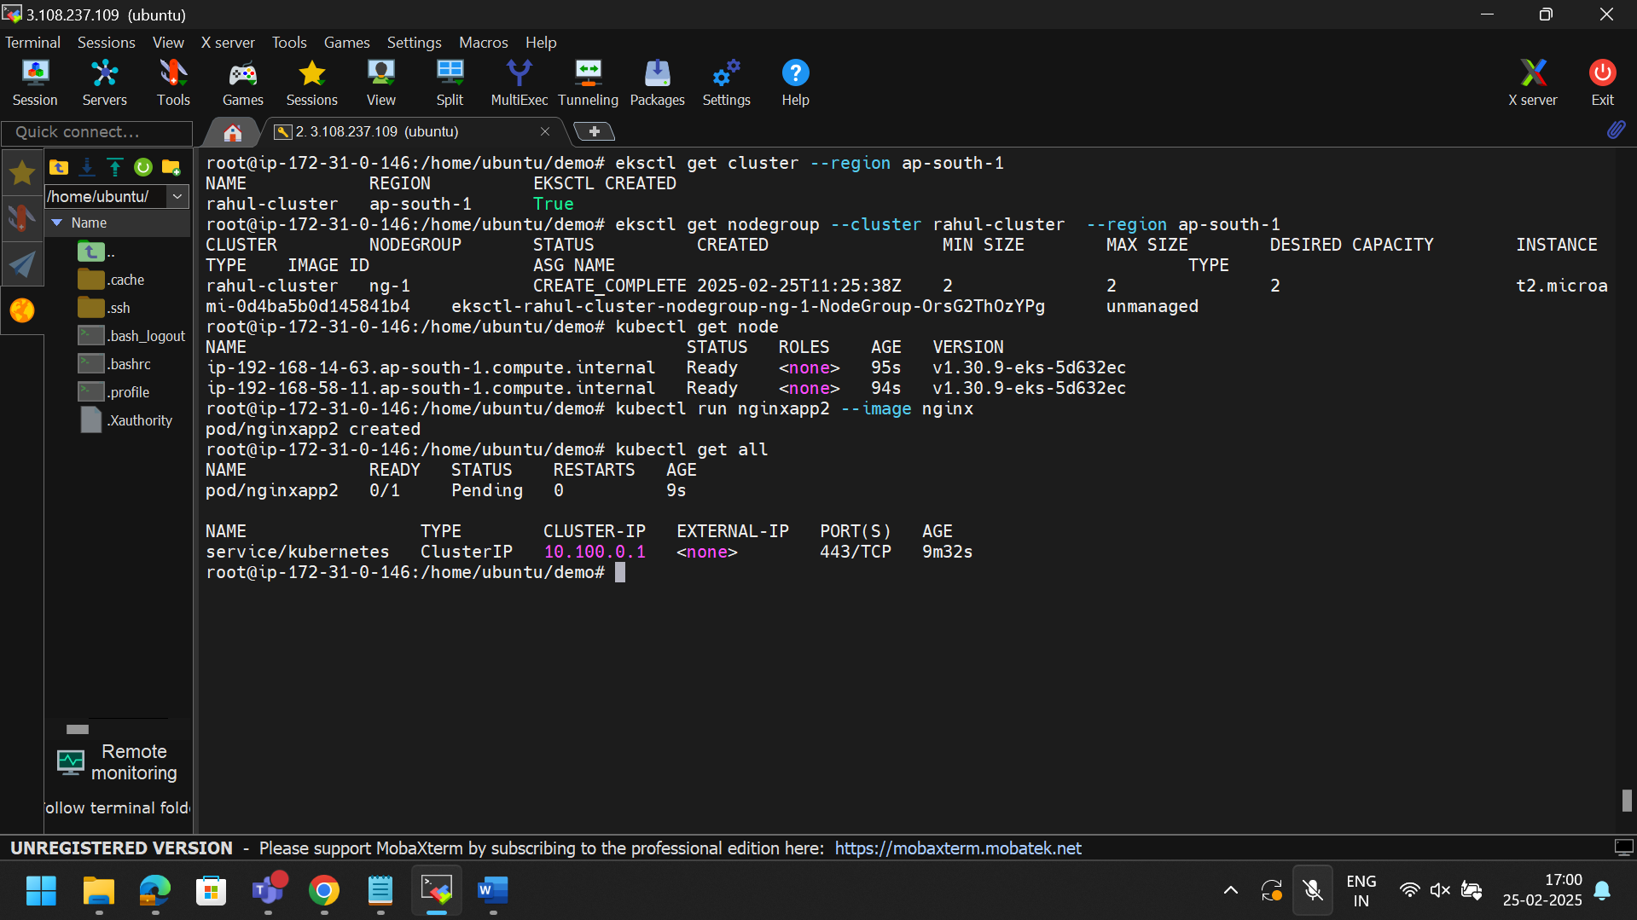

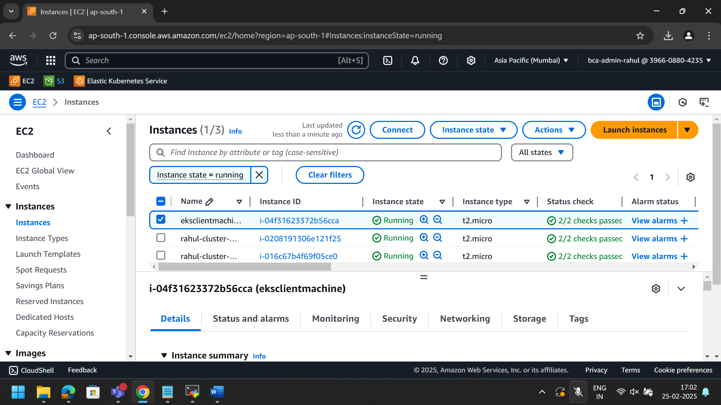

2.Using terraform

